How to debug in PyCharm

1. Configure settings file for pycharm.

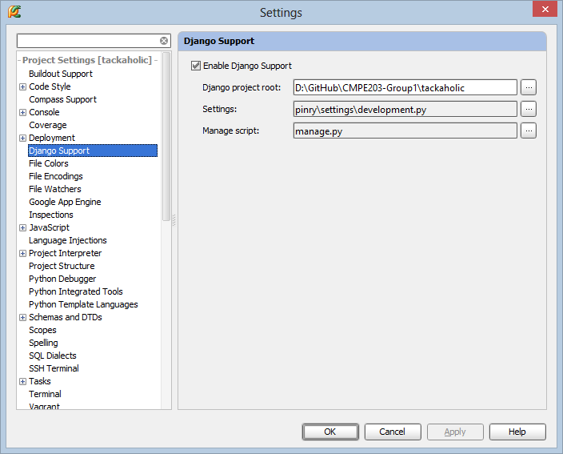

1. Edit configuration for Debug.

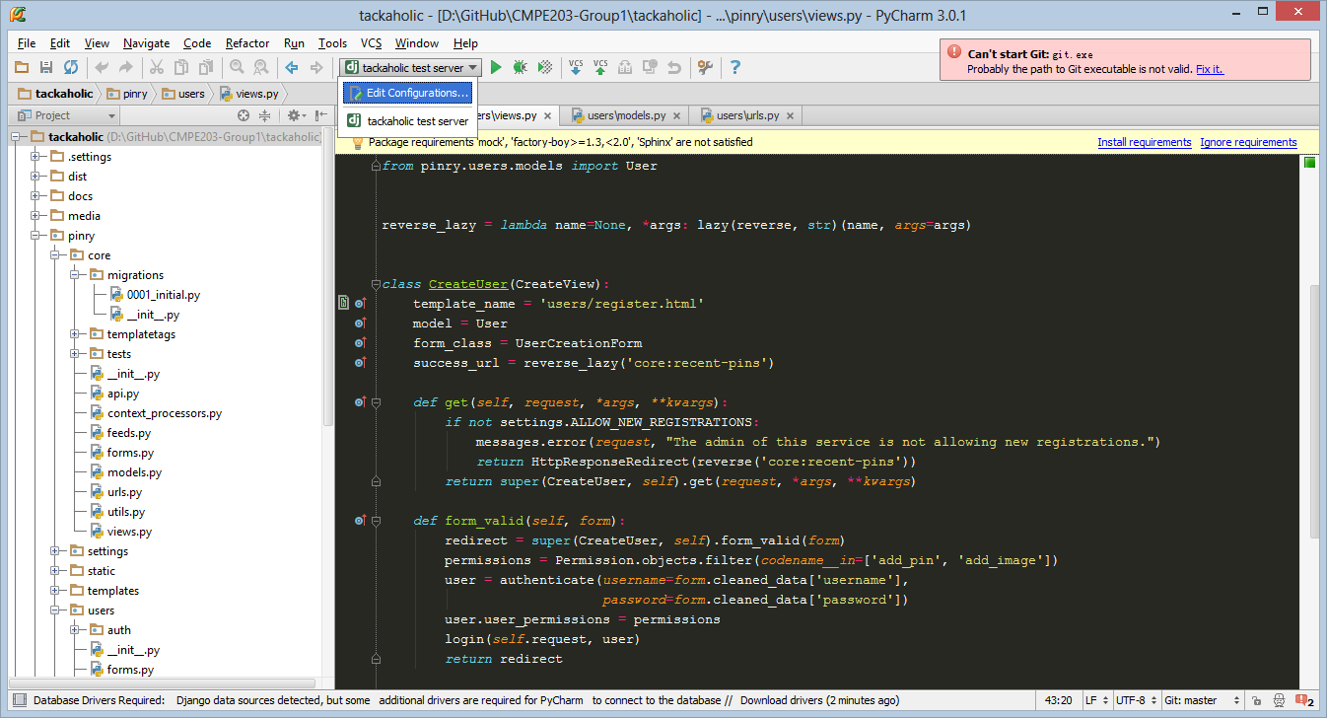

1. Create a new Run/Debug Configruation.

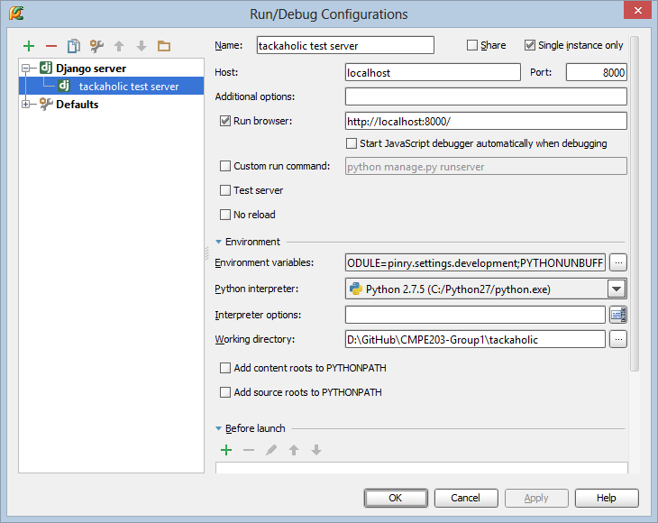

1. Click the button  to start debugging. You will see there is some information in the console which indicates the django server is started. We can set a breakpoint in the function as the image shows.

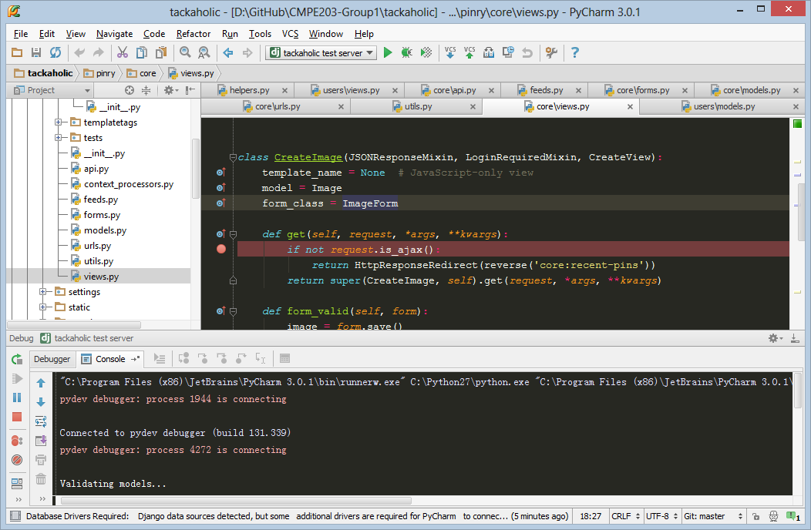

1. The browser is opened. If you try to upload new image, application execution will be pause at the breakpoint you set.

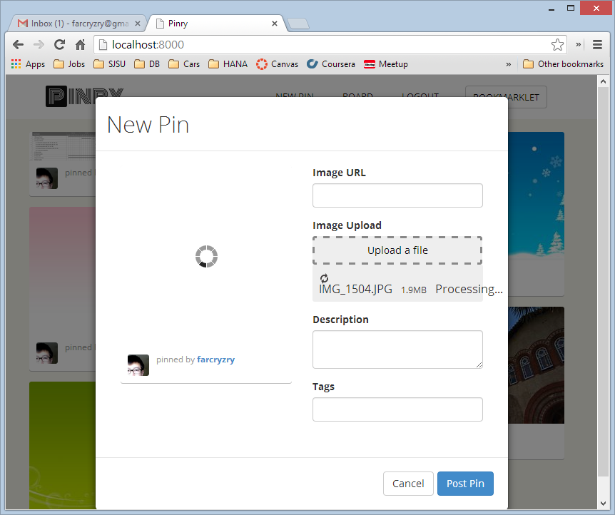

1. Now, enjoy debugging! You will be more efficient when debugging the application than just reading the code.

